**UNIVERSIDAD TECNOLÓGICA DE QUERÉTARO**



SOFTWARE REQUIREMENT ANALISYS DOCUMENT FOR THE DC MOTOR SPEED CONTROLLER

Embedded Software Course

Ugarte, Gabriela

Chavez, Jose Luis

31/10/2019

# **RECORD OF CHANGES**

\***A**-Added **M**-MODIFIED **D**-DELETED

|  |  |  |  |  |  |
| --- | --- | --- | --- | --- | --- |
| **VERSION NUMBER** | **DATE** | **NUMBER OF FIGURE, TABLE, OR PARAGRAPH** | **\*A**  **M**  **D** | **TITLE OR BRIEF DESCRIPTION** | **CHANGE REQUEST NUMBER** |
| 1 | 09/14/2019 |  |  | Initial Revision |  |
| 2 | 10/26/2019 |  | **M** – Review of requirements |  |  |
| 3 | 10/28/2019 |  |  | Second Revision |  |

Table of Contents

RECORD OF CHANGES 2

INTRODUCTION 3

PURPOSE 3

SCOPE 3

ACRONYMS AND ABBREVIATIONS 3

REQUIREMENTS 3

FUNCTIONAL 3

NON-FUNCTIONAL 10

DISPLAY APPEARANCE 10

REVIEW OF REQUIREMENTS 12

# INTRODUCTION

## PURPOSE

This document contains provisions for the processes and products related to the engineering of requirements for systems and software products and services throughout the life cycle. It defines the construct of a good requirement, provides attributes and characteristics of requirements, and discusses the iterative and recursive application of requirements processes throughout the life cycle. This document provides additional guidance in the application of requirements engineering and management processes for requirements-related activities in ISO/IEC/IEEE 12207 and ISO/IEC/IEEE 15288. Information items applicable to the engineering of requirements and their content are defined. The content of this document can be added to the existing set of requirements-related life cycle processes defined by ISO/IEC/IEEE 12207 or ISO/IEC/IEEE 15288, or can be used independently.

## SCOPE

This document provides the requirements for the processes and products of the Speed Controller for a DC Motor (SMC).

The SMC involves the development of an embedded software application using the Renesas S7G2 Starter Kit SK R7FS7G27H3A01CFC. The application will control the speed of a DC Motor and show in an LCD the RPMs and the PWM duty cycle value.

This document is an extract of ReqView Database for the Speed Motor Controller project.

## ACRONYMS AND ABBREVIATIONS

SMC – Speed Motor controller

# REQUIREMENTS

Type: Section

## FUNCTIONAL

[SMC-SWRA-44] The software shall create an input pulse train with a frequency from 100Hz to 1 KHz

Type: Functional Requirement

[SMC-SWRA-98] The software shall set the duty cycle from the input pulse train with a scale from 0% to 100 %

Type: Functional Requirement

[SMC-SWRA-88] The software shall set the input pulse train with the behavior described at SWRA-82

Type: Functional Requirement

[SMC-SWRA-82] Figure that describes the motor behavior at 13.6V without any load

Attachment: SWRA-82_1_Motor Values at 13.6V.PNG

Type: Functional Requirement

[SMC-SWRA-111] The software shall create an average of the number of pulses registered with the hall effect sensor every 100 ms +/- 10 ms of tolerance

Type: Functional Requirement

[SMC-SWRA-112] The software shall set the voltage in the potentiometer from 0V to 3.3V

Type: Functional Requirement

[SMC-SWRA-113] The software shall adjust the speed of the motor from 0RPM to 3000 RPM according to the voltage in the potentiometer as described in the [SMC-SWRA-117]

Type: Functional Requirement

[SMC-SWRA-117]

Attachment: SWRA-117_1_Pot_Voltage.PNG

Type: Functional Requirement

[SMC-SWRA-83] The software shall adjust the SetPoint using a potentiometer connected as described in the [SMC-SWRA-84]

Type: Functional Requirement

[SMC-SWRA-84] Figure that described the connection for the potentiometer.

Attachment: SWRA-84_1_Set_Point.PNG

Type: Functional Requirement

[SMC-SWRA-114] The software shall set the offset value with the average of 3 samples of the potentiometer value within 100 ms +/- 10 ms

Type: Functional Requirement

[SMC-SWRA-115] The software shall set the potentiometer adjustment as defined in the [SMC-SWRA-116].

Type: Functional Requirement

[SMC-SWRA-116] Figure that describes the control signal vs Average Speed

Attachment: SWRA-116_1_Pot_Adjustment.PNG

Type: Functional Requirement

[SMC-SWRA-118] The software shall have an open UART protocol between the PC and the board.

Type: Functional Requirement

[SMC-SWRA-119] The software shall refresh the display every 200 ms +/-20 ms of tolerance.

Type: Functional Requirement

[SMC-SWRA-120] The software shall set the UART transmition configured to 115200 bits per second.

Type: Functional Requirement

[SMC-SWRA-101] The motor shall be controlled with Dual H-Bridge Motor Driver.

Type: Functional Requirement

[SMC-SWRA-102] The motor shall have a power supply of 12 VDC

Type: Functional Requirement

[SMC-SWRA-103] The motor shall operate at a constant period when varying the duty cycle as described at [SMC-SWRA-104] and [SMC-SWRA-106]

Type: Functional Requirement

[SMC-SWRA-104] Figure that described the ON/OFF constant operation of the motor

Attachment: SWRA-104_1_Motor_Operation.PNG

Type: Functional Requirement

[SMC-SWRA-106] Figure that described the duty cycle behavior.

Attachment: SWRA-106_1_Duty_Cycle_varying.PNG

[SMC-SWRA-107] The software shall display in the LCD the information as shown at [SMC-SWRA-105]

Type: Functional Requirement

[SMC-SWRA-105] Figure that describes how the information shall be displayed in the LCD.

Attachment: SWRA-105_1_Display.PNG

Type: Functional Requirement

[SMC-SWRA-109] The software shall have a PI algorithm controller.

Type: Functional Requirement

[SMC-SWRA-101] The software shall call the algorithm controller every 100 ms +/- 10 ms.

Type: Functional Requirement

[SMC-SWRA-102] The hardware shall be connected as defined in the following image.

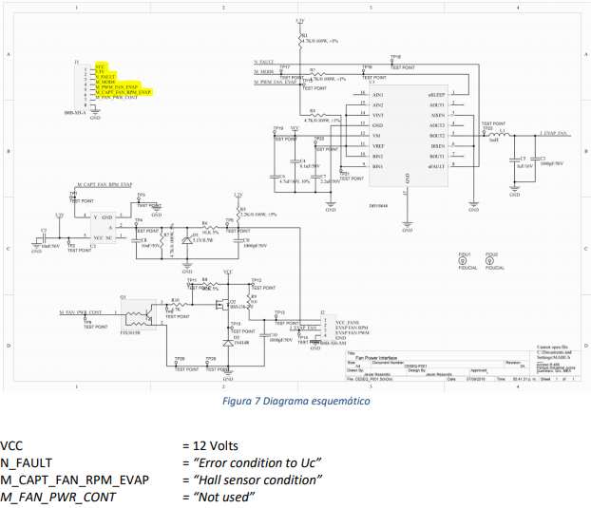

## NON-FUNCTIONAL

Type: Section

### DISPLAY APPEARANCE

[SMC-SWRA-92] The display shall have a graphic configuration as defined in the images below.

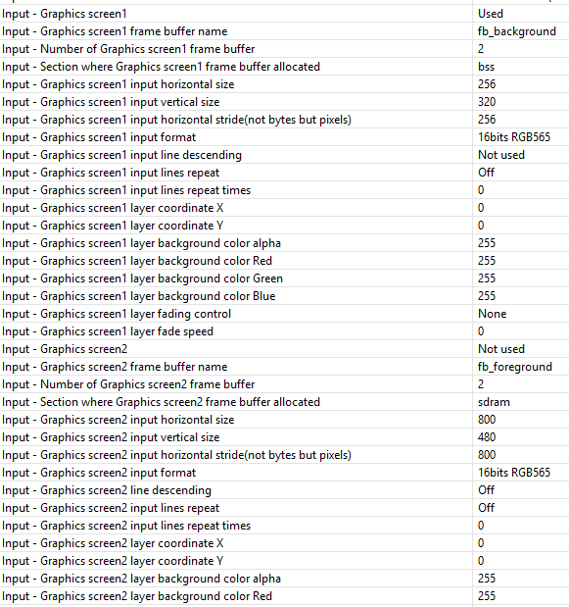

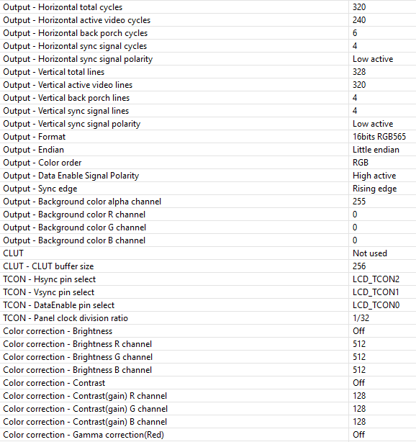

[SMC-SWRA-100] Display typography design to show the information to the user should be the following

Attachment: SWRA-100_1_Display_Typhography.PNG

# REVIEW OF REQUIREMENTS

Type: Section

After the initial revision, the following requirements were ambiguous; therefore, they were reworded to comply with the client specifications.

1. The display shall have a good contrast to allow the user see the information
2. The display shall have good illumination.
3. The display shall have the typography specified in the image below
4. The display shall display the information with the correct refreshness value

After the initial revision, the following requirement was set as functional and non-functional, after an analysis it was moved to Non-functional requirement as this does not affect the behavior of the DC Motor Speed Controller software.

1. Display typography design to show the information to the user